Contents

GENERATIVE AI 2

GENERATIVE AI VS DISCRIMINATIVE(PREDICTIVE) AI 2

LARGE LANGUAGE MODELS(LLMs) 3

LLM ARCHITECTURE 4

CORE COMPONENTS OF LLMs 5

HOW ENCODERS FIT IN? 5

HOW DECODERS FIT IN? 6

EMBEDDINGS 7

VECTOR DATABASE 8

HOW LLMS WORK 8

PROMPTS & TOKENS 10

MODEL TYPES (LLM TYPES) 12

CLASSIFICATION BASED ON – HOW THEY ARE TRAINED 13

CLASSIFICATION BASED ON – HOW THEY ARE USED 15

FINE TUNING 16

FINE TUNING TECHNIQUES 17

DIFFERENT WAYS TO FINE TUNNING A MODEL 17

RAG 19

WHAT IS RAG? 19

EXAMPLES 19

TOOLS TO BUILD RAG SYSTEMS 20

AGENTIC AI 20

EXAMPLES 20

MULTI-AGENT AGENTIC AI? 21

OPEN AI 23

AZURE OPEN AI 23

# GENERATIVE AI

What Is Generative Ai

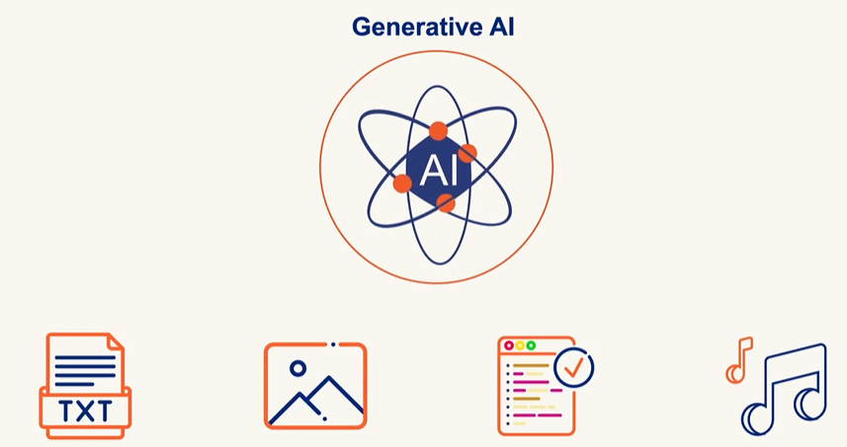

*Generative AI creates new content like Text, Image, Audio and Code based in learned Pattern unlike Traditional AI which classifies and predicts*

Generative Ai Challenges

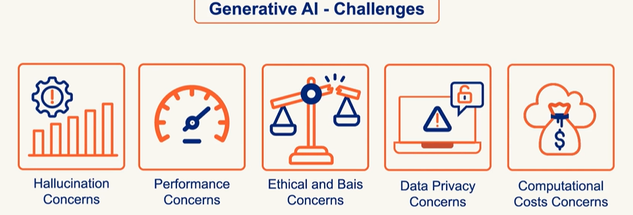

## GENERATIVE AI VS DISCRIMINATIVE(PREDICTIVE) AI

* **Generative AI models** learn the **joint probability** of inputs and outputs (P(x, y)). This means they understand how data is structured and can **generate new data** that looks similar to what they’ve seen.

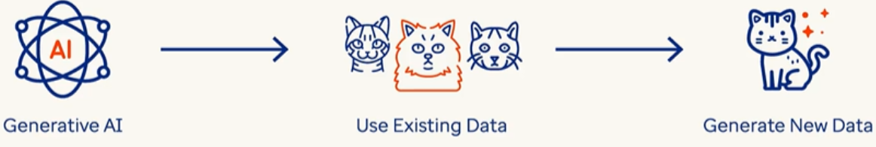

* **Discriminative AI models** learn the **conditional probability** (P(y|x))—they focus on **distinguishing** between different categories or classes. Its goal is to **classify** or **predict** based on input data.
* Example:
  + **Spam filters** classify emails as spam or not spam.
  + **Face recognition systems** identify people from images.
  + **Sentiment analysis** detects if a review is positive or negative.

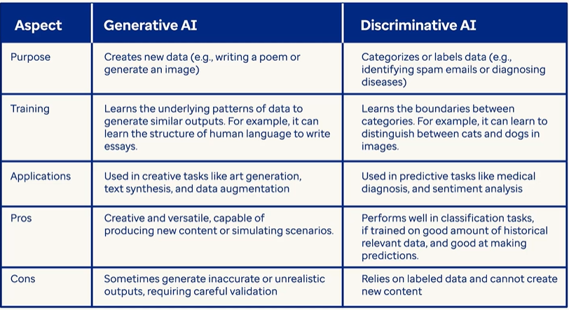

## LARGE LANGUAGE MODELS(LLMs)

* A **Large Language Model** is a type of deep learning model, typically based on the **Transformer architecture**, trained on vast corpora of text data.
* It uses **billions (or even trillions) of parameters** to learn statistical patterns in language, enabling it to perform a wide range of natural language processing (NLP) tasks such as text generation, summarization, translation, question answering, and more.
* LLMs are pre-trained on general data and can be fine-tuned for specific domains or tasks.
* Example: **ChatGPT**, **GPT-4**, **Claude**, **Gemini**, and **LLaMA**

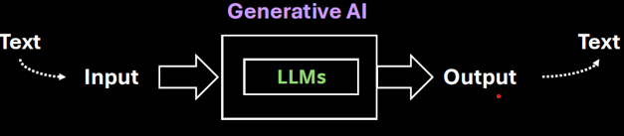

|  |
| --- |
| What are Parameters in LLM?  Simple Analogy: "Baking Cookies"  Imagine we are teaching a robot how to bake cookies. We give it a recipe, and it tries baking. Each time, it adjusts things like:   * How much sugar to use * How long to bake them * How much chocolate to add   These adjustable settings are like **parameters**. The more parameters it has, the more precisely it can tweak the recipe to make the perfect cookie.  In an LLM, instead of cookies, it’s learning **how to form sentences**. And instead of sugar and chocolate, it’s adjusting **billions of tiny knobs** that control how it understands and generates language.  In machine learning, a **parameter** is a value that the model learns during training. In LLMs:   * Each parameter is a **weight** in a neural network. * These weights determine how input words are transformed into output words. * The model adjusts these weights by analyzing **huge amounts of text** and minimizing errors in its predictions.   For example, GPT-3 has **175 billion parameters**, and GPT-4 has even more. The more parameters, the more nuanced and accurate the model can be—though it also requires more data and computing power. |

Examples of LLMs

|  |  |  |
| --- | --- | --- |
| **Model** | **Organization** | **Key Use** |
| GPT-4 | OpenAI | General purpose, ChatGPT |
| Claude | Anthropic | Helpful assistant, safety-focused |
| Gemini | Google | Multimodal AI |
| LLaMA | Meta | Open-source, research-focused |

## LLM ARCHITECTURE

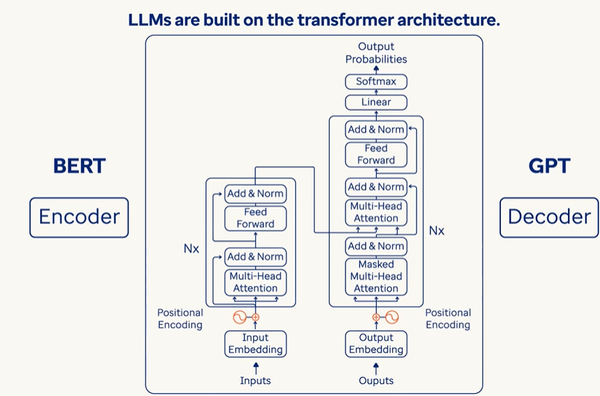  
TRANSFORMER ARCHITECTURE

The **Transformer** is the core architecture behind most modern LLMs. It consists of two main parts:

1. ENCODER STACK
2. DECODER STACK

### CORE COMPONENTS OF LLMs

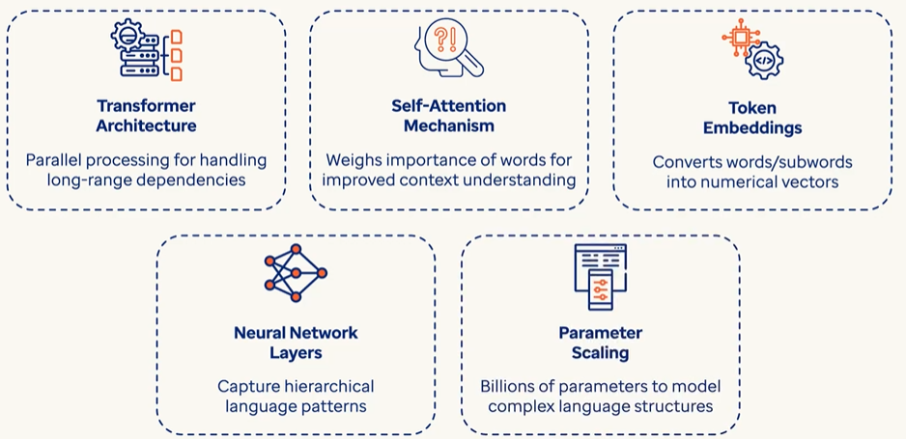

### HOW ENCODERS FIT IN?

The **encoder** in a Transformer:

* Takes an input sequence (like a sentence).
* Processes it through **self-attention** to understand relationships between words.
* Outputs a **contextualized representation** of each token.

✅ Used in models like **BERT**, which are **encoder-only** and great for understanding tasks (e.g., classification, question answering).

#### EXAMPLE

|  |  |  |  |  |  |  |  |  |
| --- | --- | --- | --- | --- | --- | --- | --- | --- |
| Let’s walk through a **simple example** to explain how the **encoder** in a Transformer works:  Input Sentence**: "The cat sat."**  Step 1: TOKENIZATION: The sentence is split into tokens: ["The", "cat", "sat"]  Step 2: Embedding + Positional Encoding : Each token is converted into a vector (embedding), and positional information is added so the model knows the order:  "The" → [0.1, 0.3, ...]  "cat" → [0.5, 0.2, ...]  "sat" → [0.4, 0.7, ...]  Step 3: Self-Attention : Now the encoder applies **self-attention**, which allows each word to "look at" the others and understand context.  For example:   * "cat" might attend to "The" to understand it's a subject. * "sat" might attend to "cat" to understand who is doing the action.   This step helps the model understand relationships like:   * Subject → "cat" * Verb → "sat" * Article → "The"   Step 4: Contextualized Representations : After self-attention and feed-forward layers, each token now has a **context-aware vector**:   |  |  | | --- | --- | | Token | Contextualized Vector (simplified) | | "The" | [0.12, 0.45, …] (knows it's an article for "cat") | | "cat" | [0.67, 0.88, …] (knows it's the subject of "sat") | | "sat" | [0.91, 0.34, …] (knows it's the action done by "cat") |   These vectors are the **encoder's output** — they’re like smart embeddings that understand the sentence structure and meaning. |

### HOW DECODERS FIT IN?

The **decoder** in a Transformer:

* Takes the encoder's output (if present) and previously generated tokens.
* Uses **masked self-attention** to prevent peeking ahead.
* Uses **encoder-decoder attention** to focus on relevant input parts.

Outputs the next token in a sequence.

✅ Used in models like **GPT**, which are **decoder-only** and great for **text generation**.

#### EXAMPLE

|  |  |  |  |  |  |  |  |  |  |  |  |  |  |  |  |  |  |  |  |  |
| --- | --- | --- | --- | --- | --- | --- | --- | --- | --- | --- | --- | --- | --- | --- | --- | --- | --- | --- | --- | --- |
| Let’s continue with the same example sentence: **"The cat sat."** Now imagine we want the Transformer to **generate this sentence** using the **decoder**.  Step 1: Input from Encoder  The **encoder** has already processed the sentence and produced **contextualized representations** for:   * "The" → [0.12, 0.45, ...] * "cat" → [0.67, 0.88, ...] * "sat" → [0.91, 0.34, ...]   These are passed to the **decoder**.  Step 2: Start Token   * The decoder begins with a special token like <START> to initiate generation.   Step 3: Masked Self-Attention  The decoder uses **masked self-attention** to look only at **previous tokens**, not future ones. This prevents it from "cheating" by seeing the full sentence ahead of time.  Example:   * At first step, it only sees <START> * At second step, it sees <START>, "The" * At third step, it sees <START>, "The", "cat" * And so on…   Step 4: Encoder-Decoder Attention  At each step, the decoder **attends to the encoder's output** to understand the context of the input sentence.  Example:   * When generating "cat", it looks at the encoder's representation of "The" and "cat" * When generating "sat", it attends to "The", "cat", and their relationships   Step 5: Output Token  The decoder predicts the next token in the sequence:   * <START> → "The" * "The" → "cat" * "cat" → "sat" * "sat" → <END>   Each prediction is based on:   * Previously generated tokens * Encoder's contextual output * Attention mechanisms   **Summary in Context of "The cat sat."**   |  |  |  |  |  | | --- | --- | --- | --- | --- | | Step | Decoder Input | Masked Self-Attention | Encoder-Decoder Attention | Output | | 1 | <START> | Only <START> | Looks at encoder output | "The" | | 2 | <START> The | <START>, "The" | Looks at encoder output | "cat" | | 3 | <START> The cat | All previous tokens | Looks at encoder output | "sat" | |

Encoder-Decoder Together

In full **Transformer models** (like **T5**, **BART**, or **original Transformer for translation**):

* The **encoder** reads the input (e.g., English sentence).
* The **decoder** generates the output (e.g., French translation), attending to the encoder's output.

LLM Variants Based on Transformer

|  |  |  |  |  |
| --- | --- | --- | --- | --- |
| Model Type | Uses Encoder | Uses Decoder | Example Models | Best For |
| Encoder-only | ✅ Yes | ❌ No | BERT, RoBERTa | Understanding tasks |
| Decoder-only | ❌ No | ✅ Yes | GPT-2, GPT-3, GPT-4 | Text generation, chat |
| Encoder-Decoder | ✅ Yes | ✅ Yes | T5, BART, Marian | Translation, summarization |

## EMBEDDINGS

* Embeddings are numerical representations of text—a way to convert words into numbers so machines can understand and process them.
* Machines do not inherently understand text; they operate using numbers. Embeddings allow machine learning models to interpret meaning, context, and relationships between words.

**KEY FUNCTIONALITY OF EMBEDDINGS**

1. **CAPTURING MEANING**: Embeddings reflect the semantic meaning of words or sentences.
2. **CONTEXT UNDERSTANDING**: Embeddings account for the context of text (e.g., same word in different sentences/sentiments - “great” in sarcasm vs happiness).

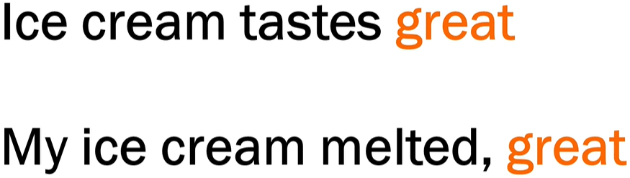

1. **RELATIONSHIPS**:

* Words with strong associations (e.g., "ice" and "cream") have similar embeddings, reflecting their connection.
* Models understand the proximity and sequence of words based on embeddings.

**HOW EMBEDDINGS ARE GENERATED**

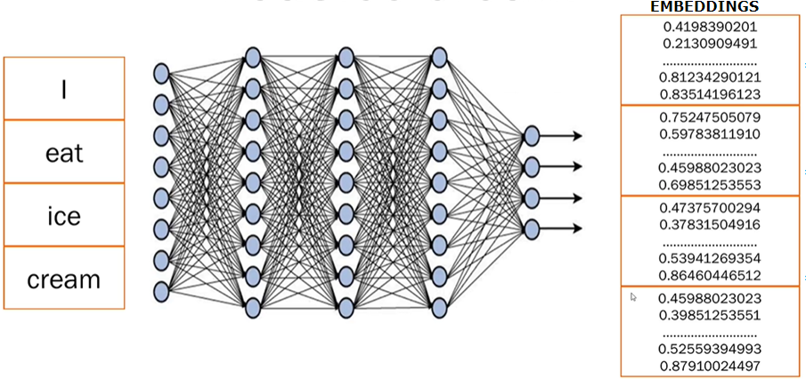

1. **STEP 1:** **BREAKING TEXT INTO TOKENS**

* Sentences are broken into smaller pieces or tokens (e.g., splitting "I eat ice cream" into 4 tokens—"I", "eat", "ice", "cream").

2. **STEP 2: NEURAL NETWORK PROCESSING**:

* Trained **transformer models** analyze the text, generate embeddings, and capture meaning, context, and relations between tokens.

1. **STEP 3: NUMERICAL EMBEDDINGS:**

* Each token is converted into numerical data (random numbers).
* These numbers represent embeddings, storing all learned information about the word or sentence.
* Only the transformer model understands what these embeddings mean based on its training.

## VECTORS

A **vector** is a list of numbers that represents something—like a word, an image, or even a sentence—in a way that a computer can understand and work with.

|  |  |
| --- | --- |
| Simple Analogy | |
| Imagine we want to describe a fruit (say, an **apple**) using numbers:   * Sweetness: 8 * Crunchiness: 7 * Juiciness: 6   We could represent the apple as a vector: [8, 7, 6]  Now, a **banana** might be:[9, 3, 7]  These vectors help a computer compare fruits based on their features. |  |

In Language Models

When we talk about **words**, we turn them into vectors using **embeddings**. For example:

* “cat” → [0.12, -0.45, 0.88, ..., 0.03]
* “dog” → [0.10, -0.40, 0.85, ..., 0.05]

These vectors are **high-dimensional** (often 300 to 1,000+ numbers long) and capture the **meaning** of the word based on how it’s used in language.

### WHY ARE VECTORS USEFUL?

They allow computers to:

* **Compare** things (e.g., how similar two words or images are)
* **Search** by meaning (semantic search)
* **Cluster** similar items together
* **Feed data into machine learning models**

## VECTOR DATABASE

A **vector database** is a special kind of database designed to store and search **vectors (***which are just lists of numbers that represent things like text, images, or audio in a way that computers can understand*.)

Why Vectors?

* When you use **embeddings** (like we discussed earlier), we turn data (like the word *“cat”*) into a vector, such as:

**[0.12, -0.45, 0.88, ..., 0.03]**

* These vectors capture **meaning** and **context**. But once we have millions of them, we need a smart way to **store** and **search for** them efficiently. That’s where vector databases come in.

What Does a Vector Database Do?

It helps to:

* **Store** millions or billions of embeddings
* **Search** for the most similar vectors (e.g., “find texts similar to this one”)
* **Rank** results by similarity (using distance metrics like cosine similarity)

Real-World Example

Let’s say we run a **document search engine**:

1. We convert all the documents into vectors using an LLM.
2. We store those vectors in a vector database (like **Pinecone**, **Weaviate**, **FAISS**, or **Milvus**).
3. When a user asks a question, we:
   * Convert the question into a vector
   * Search the database for the **most similar document vectors**
   * Return the most relevant documents

## HOW LLMS WORK

1. Training Phase

* The LLM is trained using **self-supervised learning**: it learns by predicting **missing words** in a sentence.
* For example: "The cat sat on the ___." → Model tries to guess "mat".
* It sees **billions or trillions of words** from diverse sources, learning grammar, facts, reasoning patterns, and even some coding skills.

2. Tokenization

* Text is broken down into **tokens** (which may be words, subwords, or characters).
* For example, “ChatGPT is smart” → ["Chat", "G", "PT", "is", "smart"].

3. Transformer Architecture

* A special deep learning model that uses **attention mechanisms** to understand the context of each word in relation to others in the sentence.
* For example, it knows the word “bank” can mean money or river, depending on context.

4. Inference (When You Use It)

* When you type a prompt, the LLM:
  + Converts your input into tokens.
  + Uses its trained model to predict the **next best token**.
  + Repeats until it completes a meaningful output.
* This happens very fast — like autocomplete on steroids.

What Can LLMs Do?

Answering questions

* Write essays, emails, or stories
* Translate languages
* Generate code
* Summarize documents
* Act as chatbots
* Reason through logic puzzles (to some extent)

Why it feels like LLMs are answering questions

* It feels like an LLM is answering questions because it has learned to predict the next token in a way that mimics intelligent responses — by learning patterns from millions of real questions and answers.

|  |  |  |
| --- | --- | --- |
| When we ask:  > "What is the capital of France?" | The model sees a familiar pattern. It has seen many examples like this during training:  Q: What is the capital of France?  A: Paris  Q: What is the capital of Germany?  A: Berlin | So, it has learned that when someone types:  > "What is the capital of ___?"  The best next tokens are usually:  > " [Country name]" → "?" → " A: [Capital]"  So it predicts:  " Paris"   * That’s it. It doesn’t "know" what Paris is — it just has seen that people answer that question with “Paris” so many times that it becomes the most likely token sequence. |
| **Chain of Tokens Feels Like Thought**  Let’s say we ask:  > "Can you explain black holes?" | It starts predicting:  "Sure! A black hole is a region in space..."  Then it keeps going with:  "...where gravity is so strong that not even light can escape..."   * Each time, it's predicting the next most likely token, based on what it has already said and what it's seen in similar explanations before. | * This sequence of predictions sounds natural, structured, and smart — because it's imitating how humans write or speak. * It's Like a Super Autocomplete |

Analogy: The Super Parrot with a Giant Memory

Imagine a **super parrot** named **GPTy** who has:

1. **Read every book**, website, chat, and textbook ever written.
2. **Doesn’t understand the world**, but **remembers how humans talk** — sentence by sentence.

Now, we ask the parrot: “What is the capital of Japan?"

* GPTy searches its memory and remembers **100,000+ times** someone asked that same question, and people always replied: "Tokyo."
* So it just **repeats the most likely answer** it has seen:→ **"Tokyo"**

|  |  |
| --- | --- |
| **Simple Simulation (in Code)**  Let’s simulate a tiny LLM that only learned how to respond to one question:  def tiny_model(prompt):  if prompt == "What is 2 + 2?":  return "4"  elif prompt.startswith("What is"):  return "I'm not sure, but maybe check a calculator!"  else:  return "Can you ask that again?" | print(tiny_model("What is 2 + 2?")) # → 4  print(tiny_model("What is 10 x 10?")) # → "I'm not sure..."  print(tiny_model("Tell me a joke.")) # → "Can you ask that again?"  That’s basically what a real LLM does — except:   * It doesn't have **if-else** rules. * It has **math-based probabilities** to guess the next best word/token. * It was trained on **terabytes** of data, not 3 lines like our tiny version. |

### PROMPTS & TOKENS

**WHAT IS A PROMPT?**

* A **prompt** is the **input** we give to a language model — it's the question, instruction, or text we type to get a response. We Think of it like a **conversation starter** or a **command**.It can be a single word, a sentence, or a long paragraph.

**WHAT IS A TOKEN?**

* A **token** is a **chunk of text** — usually a word or part of a word — that the model processes. It is numerical representation (converted by Tokenizer)of word or parts of word , phrases or a character
* Tokens can be as short as one character or as long as one word.
* For example:
  + "ChatGPT" → 1 token
  + "unbelievable" → might be split into ["un", "believ", "able"] → 3 tokens
  + "I am happy." → 4 tokens (["I", " am", " happy", "."])
* Most models (like GPT-4) use a tokenizer to split text into tokens. The number of tokens affects:
  + **Cost** (for API usage)
  + **Speed**
  + **Context limit** (e.g., GPT-4-turbo can handle up to 128k tokens)

|  |
| --- |
| * The set of all tokens used by the model is called the vocabulary of the model * The process of splitting text into tokens is called tokenization. |

**TOKENS IN CHAT GPT**

|  |  |
| --- | --- |
|  | Open the URL: <https://platform.openai.com/tokenizer>  Enter the desired prompt  It will show how many has been created for a given prompt along with attention score (based on color code)  Note : Each model tokenize the prompt differently as they use different tokenizers |

#### TOTAL TOKENS

* Tokens are numerical representation of characters, words or phrases

|  |
| --- |
| * Tokens are a fundamental metric for measuring usage in an AI system. * **Total tokens = Input tokens (**The number of tokens in the prompt or message you send**) + Output tokens(**The number of tokens in the model's response**)**   . **WHY IT MATTERS?**   * Language models have a **token limit** per interaction (e.g., 8,000 or 32,000 tokens depending on the model). * If the total number of tokens exceeds the limit, the model may truncate the input or fail to generate a complete response. |

##### CONTEXT WINDOW

* The context window refers to the maximum number of tokens (input + output) that the model can "see" or process at one time.
* The context window includes:
  + **Your input (prompt, messages, instructions)**
  + **The model’s output (response)**
  + **Any previous conversation history (if it's part of the current session)**
* Different models have different context window sizes. For example:
  + GPT-3.5: ~4,096 tokens
  + GPT-4 (standard): ~8,192 tokens
  + GPT-4 Turbo: up to 128,000 tokens

**WHY DO IT MATTERS?**

* If the conversation exceeds the context window, older parts of the conversation may be truncated or forgotten.
* This affects the model’s ability to maintain long-term coherence or remember earlier details.
* For example, a LLM with context window of 10K, which is fed by an article of 15K token – it will truncate the token after 10K tokens of the Article. Hence the long documents may need to be chunked to fit within the context window of the LLM

## MODEL TYPES (LLM TYPES)

### CLASSIFICATION BASED ON – HOW THEY ARE TRAINED

BASE MODEL

|  |  |
| --- | --- |
|  | * Base MODEL: The base model is outcome of pre-training phase on a large corpus of text using self-supervised learning (e.g., predicting the next word). * These models can process language but not optimized for further adaptation. |

|  |
| --- |
| * Self-supervised learning is a type of machine learning where a model learns from unlabeled data by creating its own labels from the data itself.   **HOW IT WORKS**  Imagine a sentence:  "The cat sat on the ___."  The model is trained to predict the missing word ("mat") using the rest of the sentence. No human labeled this data — the model learns by solving puzzles it creates from raw text.  **KEY FEATURES:**   * No manual labeling needed. * The model learns patterns, grammar, and meaning from large text corpora. * Used heavily in training base models like BERT, GPT, etc. |

* + Purpose: Learns general language patterns, grammar, facts, and reasoning.
  + Example: GPT-3 before any fine-tuning.
  + Limitation: Not optimized for specific tasks or instructions.

Foundational Model

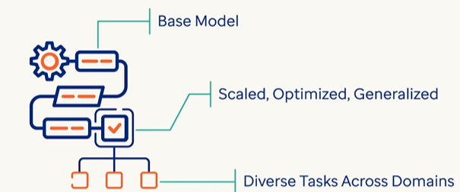

* A broader term that includes base models and other large-scale models trained on diverse data.
* Built on base model – which are scaled , optimized for multitask adaptability
* It can perform diverse task across multiple domains without requiring task specific training.
  + Purpose: Acts as a foundation for building more specialized models.
  + Example: PaLM, GPT-4, LLaMA—used as starting points for downstream tasks.
  + Note: All base models are foundational, but not all foundational models are used as-is.

Instruction-Tuned MODEL

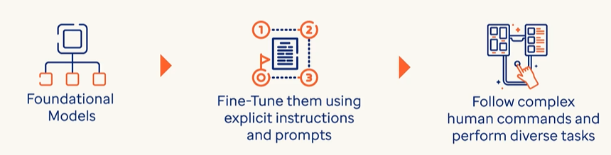

* A foundational or base model further trained to follow natural language instructions.
  + Purpose: Makes the model more helpful, safe, and aligned with human intent.
  + How: Trained on datasets like “prompt → response” pairs.
  + Example: InstructGPT, ChatGPT.

Fine-Tuned Model

* A model adapted to perform specific tasks or domains (e.g., legal, medical, customer support).
* The base model is further tuned using dataset using supervised learning.

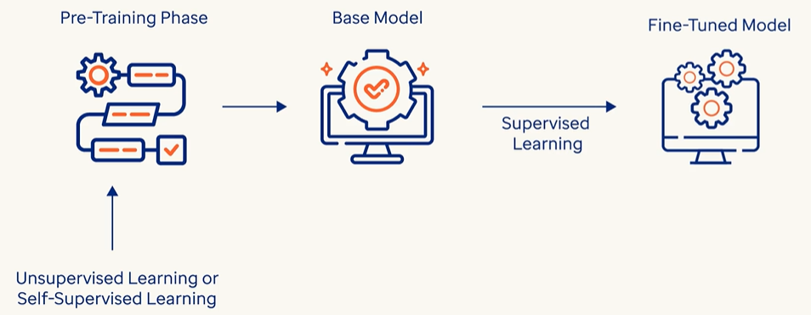

* Purpose: Improves performance on narrow use cases.
* How: Trained on labeled data or domain-specific examples.
* Example: A GPT model fine-tuned for legal document summarization.

### CLASSIFICATION BASED ON – HOW THEY ARE USED

#### GENERAL PURPOSE AND DOMAIN-SPECIFIC LLMS

The distinction between General Purpose LLMs and Domain-Specific LLMs lies in their training data, capabilities, and intended use cases.:

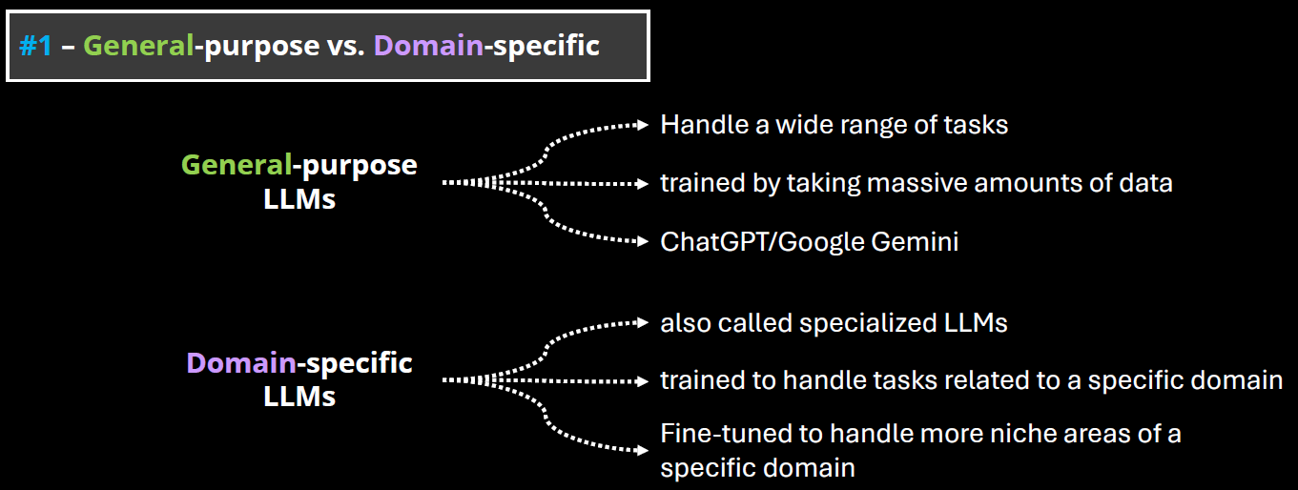

##### GENERAL PURPOSE LLMS

* These are large language models trained on a broad and diverse dataset that spans many domains (e.g., science, literature, law, medicine, pop culture, etc.).
* Examples: GPT-4, Claude, Google Gemini, LLaMA.
* Strengths:
  + Versatility: Can handle a wide range of tasks (e.g., summarization, translation, coding, creative writing).
  + Adaptability: Can generalize well across different topics and user needs.
  + Scalability: Useful in applications where domain-specific knowledge is not required.
* Limitations: May lack deep expertise in specialized fields.

##### DOMAIN-SPECIFIC LLMS

* These are LLMs trained or fine-tuned on specialized datasets from a particular field (e.g., legal, medical, financial, scientific).
* Examples: Med-PaLM (medical), FinGPT (finance), BioGPT (biomedical), Legal-BERT (legal texts)
* Strengths:
  + High accuracy in domain-specific tasks.
  + Better understanding of terminology, context, and nuances in the field.
  + Often used in regulated industries where precision is critical.
* Limitations:
  + Limited generalization outside their domain.
  + May require frequent updates to stay current with domain knowledge.
  + Less flexible for multi-domain tasks.

##### OPEN AND CLOSED SOURCE LLMs

**The distinction between Open-Source and Closed-Source LLMs revolves around accessibility, transparency, control, and community involvement.**

###### OPEN-SOURCE LLMS

* These models have their code, weights, and training data (or methodology) publicly available. Anyone can inspect, modify, or fine-tune them.
* Examples: Meta’s LLaMA (e.g., LLaMA 2, LLaMA 3), Mistral, Falcon,OpenChat, BLOOM (by BigScience)

CLOSED-SOURCE LLMS

* These models are proprietary. The model weights, training data, and architecture details are not publicly available.
* Examples: OpenAI’s GPT-4, Anthropic’s Claude, Google’s Gemini, , Cohere Command R+,Amazon Titan

## FINE TUNING

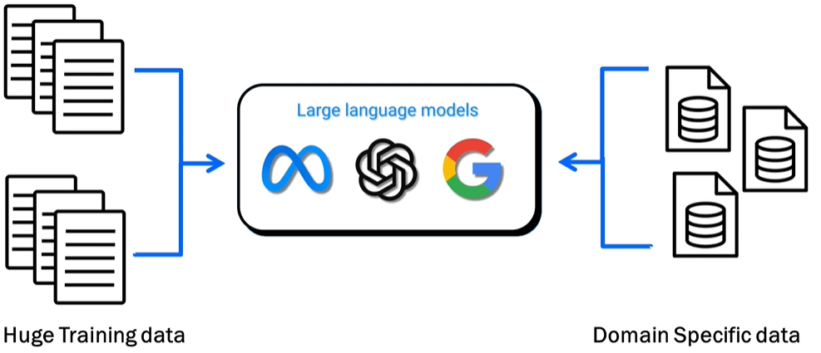

WHAT IS FINE TUNING

* Adjusting a pre-trained large language model (LLM) to provide better results on specific tasks or domain-specific datasets (e.g., healthcare, finance, etc.).

WHAT IS THE PURPOSE OF FINE TUNING

* Enhance the model's ability to generate focused and precise results on specialized datasets.
* Example: Fine-tuning an LLM on medical data improves its accuracy in answering medical queries compared to a general-purpose/pre-trained model.

### FINE TUNING TECHNIQUES

**1. Full Fine-Tuning**

**What it is**: Updating all model parameters using labeled data.

**Pros**: High flexibility and performance gains.

**Cons**: Computationally expensive, risk of overfitting, requires large datasets.

**Use case**: Domain-specific models (e.g., legal, medical).

**🧩 2. Adapter-Based Fine-Tuning**

**What it is**: Introduces small trainable modules (adapters) between layers of the frozen base model.

**Pros**: Efficient, modular, avoids catastrophic forgetting.

**Popular variants**: AdapterFusion, Compacter.

**Use case**: Multi-task learning, low-resource environments.

**🧠 3. LoRA (Low-Rank Adaptation)**

**What it is**: Injects low-rank matrices into the attention layers to reduce the number of trainable parameters.

**Pros**: Lightweight, fast training, minimal memory footprint.

**Use case**: Personalization, rapid prototyping.

**🧵 4. Prefix Tuning / Prompt Tuning**

**What it is**: Learns a fixed set of tokens (prefix or prompt) that steer the model’s behavior.

**Pros**: Extremely parameter-efficient, fast.

**Cons**: Limited flexibility compared to full fine-tuning.

**Use case**: Task-specific tuning, few-shot learning.

**🧪 5. Instruction Tuning**

**What it is**: Fine-tuning on datasets where tasks are framed as instructions.

**Pros**: Improves generalization across tasks, aligns model behavior with human intent.

**Use case**: Chatbots, general-purpose assistants.

**🧬 6. Reinforcement Learning from Human Feedback (RLHF)**

**What it is**: Uses human preferences to guide model outputs via reinforcement learning.

**Pros**: Aligns model with human values, improves helpfulness and safety.

**Cons**: Complex pipeline, expensive to scale.

**Use case**: Alignment-focused models like ChatGPT.

**🧮 7. Quantization-Aware Fine-Tuning**

**What it is**: Fine-tuning while converting model weights to lower precision (e.g., INT8).

**Pros**: Reduces model size and inference cost.

**Use case**: Edge deployment, mobile devices.

### DIFFERENT WAYS TO FINE TUNNING A MODEL

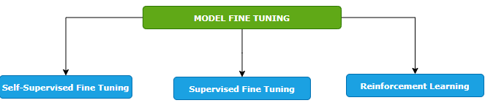

#### SELF-SUPERVISED FINE TUNING

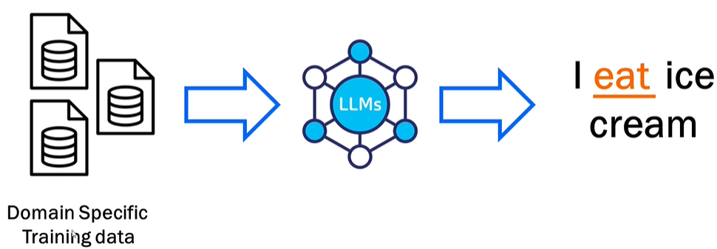

* Training the model on a domain-specific dataset. Means – we give the foundation model a big pile of training data that is specific to our domain, and the model will learn from it. In this way, the model learns to predict missing pieces of data.
* Example - when we say I ice cream, the model predicts that the missing word is eat.
* This is like how the foundation model is trained but the key difference here is that we are fine tuning the model by providing the domain specific data set. Example - Like if we want to train it on health care data set, we will pass it - the drug structure, scientific studies, all the documents that are related to drug and the model will learn from it and it would be able to generate content based on that.

#### SUPERVISED FINE TUNING

* The model is trained using a labeled dataset where both inputs and outputs are provided.
* Example: Input: "How do I find a broken bone?" → Output: "X-ray."
* Helps the model learn more precise responses based on labeled data.

#### REINFORCEMENT LEARNING

|  |  |
| --- | --- |
|  |  |
| **LOW SCORE FOR BAD RESULT** | **HIGH SCORE FOR GOOD RESULTS** |

* **Feedback-based learning**.
* The model generates outputs, and scores are assigned based on quality (high score for good results, low score for bad results).
* The model learns overtime from the feedback to improve predictions.

#### KEY FEATURES OF FINE TUNING

1. **STARTS FROM A PRE-TRAINED MODEL**: Fine tuning builds on top of a foundation model already trained on large datasets—it does not start from scratch.
2. **REQUIRES DOMAIN-SPECIFIC DATA**: We must provide good-quality, specific data for training tailored to your use case (e.g., drug data for healthcare).
3. **No Universal SOLUTION**: Each task/use case is unique, requiring case-specific implementation and variations.
4. **ITERATIVE PROCESS**: Fine tuning is repetitive and requires multiple cycles of iteration and adjustments for optimal results.

## RAG

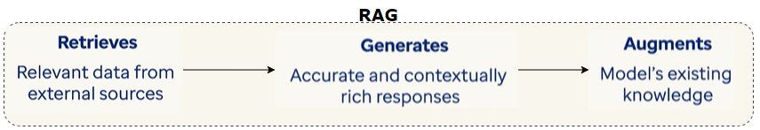

### WHAT IS RAG?

* **Retrieves relevant documents** from an external knowledge source (like a database or search engine),
* Then **generates a response** using those documents as context rather than generating response based on static data used during training
* This helps LLMs answer questions more accurately, especially when the information is **not in the model’s training data** or needs to be **up-to-date**.

RAG Architecture Overview

1. **Query Encoder**: Converts the user’s question into a vector.
2. **Retriever**: Searches a document store (e.g., FAISS, Elasticsearch) for relevant texts.
3. **Generator**: Uses the retrieved documents + the original query to generate a response.

Why RAG is Useful

| **Feature** | **Benefit** |
| --- | --- |
| **Dynamic Knowledge** | Can use updated or proprietary data |
| **Reduced Hallucination** | Grounds answers in real documents |
| **Domain Adaptability** | Easily integrates with custom corpora |
| **Cost-Efficient** | Avoids retraining large models |

### EXAMPLES

|  |
| --- |
| Simple Example   1. **User asks a question** → e.g., *"What are the benefits of using Kubernetes?"* 2. **Retriever fetches relevant documents** → From a knowledge base, database, or web search. 3. **Generator uses those documents to answer** → The LLM generates a response using the retrieved context. |
| Healthcare Chatbot for Prescriptions  **Use Case**: A patient asks:  *"Can I take ibuprofen with Metformin?"*  **RAG Flow**:   * **Retriever** finds a medical FAQ: *"Ibuprofen may increase the risk of kidney issues when taken with Metformin."* * **Generator** responds:   *"It’s advised to consult a doctor before combining ibuprofen with Metformin, as it may affect kidney function."*  ✅ **Grounded in real medical data**, not just model memory. |
| Enterprise Knowledge Assistant  **Use Case**: An employee asks:  *"What is our company’s travel reimbursement policy?"*  **RAG Flow**:   * **Retriever** pulls from internal HR documents. * **Generator** summarizes the policy:   *"Employees can claim travel expenses up to ₹10,000 per trip with prior approval from their manager."*  ✅ **Uses internal documents**, not public data. |
| Academic Research Assistant  **Use Case**: A student asks:  *"What are recent advancements in quantum computing?"*  **RAG Flow**:   * **Retriever** pulls from arXiv papers or IEEE articles. * **Generator** summarizes:   *"Recent work includes quantum error correction using surface codes and improvements in superconducting qubit coherence times."*  ✅ **Up-to-date and citation-ready**. |
| E-commerce Support Bot  **Use Case**: A customer asks:  *"What’s the return policy for electronics?"*  **RAG Flow**:   * **Retriever** finds the policy page. * **Generator** replies:   *"Electronics can be returned within 15 days if unopened and in original packaging."*  ✅ **Accurate and policy-compliant**. |

### TOOLS TO BUILD RAG SYSTEMS

* **Retrievers**: FAISS, Elasticsearch, Weaviate
* **Generators**: OpenAI GPT, HuggingFace Transformers, Mistral
* **Frameworks**: LangChain, Haystack, LlamaIndex
* **Data Sources**: PDFs, websites, databases, internal docs

# AGENTIC AI

**Agentic AI** refers to AI systems that can **autonomously make decisions**, **take actions**, and **pursue goals** with minimal human intervention. These systems behave like **agents** — they don’t just respond to prompts, they **act independently** based on objectives, rules, and environmental feedback.

## EXAMPLES

|  |
| --- |
| AI Health Assistant (Personal Agent)  Scenario: A patient says: "Help me manage my diabetes."  *Agentic AI Actions:*   1. Retrieves your medical history and prescriptions. 2. Sets reminders for medication and meals. 3. Orders refills from the pharmacy. 4. Alerts your doctor if blood sugar readings are abnormal. 5. Adjusts your diet plan based on recent activity.   ✅ Autonomous, goal-driven, multi-step behavior. |
| AI Executive Assistant (e.g., AutoGPT)  Scenario:You say: "Plan a business trip to Mumbai next week."  *Agentic AI Actions:*   1. Searches for flights and books the best one. 2. Reserves a hotel near your meeting location. 3. Schedules meetings with clients. 4. Adds everything to your calendar. 5. Sends confirmation emails.   ✅ It acts like a human assistant, not just a chatbot. |
| 3. DevOps Agent  Scenario: "Monitor my app and scale it if traffic spikes."  *Agentic AI Actions:*   * Monitors server metrics. * Detects a traffic spike. * Automatically scales up resources. * Sends a Slack alert to the team. * Rolls back if errors increase.   ✅ Autonomous infrastructure management. |
| E-commerce Store Manager Bot  Scenario:"Manage my online store."  *Agentic AI Actions:*   1. Updates product listings. 2. Adjusts prices based on competitor data. 3. Responds to customer queries. 4. Flags suspicious orders. 5. Launches a weekend sale campaign.   ✅ Acts with initiative and adapts to changing conditions. |

## MULTI-AGENT AGENTIC AI?

* **Multi-Agent Agentic AI** is an advanced design pattern where **multiple autonomous AI agents** collaborate (or sometimes compete) to solve **complex, multi-step problems**. Each agent is **specialized**, goal-driven, and capable of acting independently — but they also **communicate and coordinate** with each other to achieve a shared objective.

|  |  |
| --- | --- |
| Concept | Description |
| Agentic AI | AI that can act autonomously to achieve goals |
| Multi-Agent System (MAS) | A system where multiple agents interact to solve problems |
| Specialization | Each agent is skilled in a specific domain or task |
| Coordination | Agents share information and plan together |
| Autonomy | Agents can make decisions and take actions without human input |

Example 1: Software Development Team (AI Agents)

Imagine building a web app using only AI agents:

|  |  |
| --- | --- |
| Agent | Role |
| 🧠 Planner Agent | Breaks down the project into tasks |
| 💻 Coder Agent | Writes backend and frontend code |
| 🎨 Designer Agent | Creates UI/UX mockups |
| 🧪 Tester Agent | Writes and runs test cases |
| 📦 DevOps Agent | Deploys the app to the cloud |

They **collaborate like a real team**, using tools like GitHub, CI/CD pipelines, and Slack.

Example 2: Healthcare Automation

|  |  |
| --- | --- |
| Agent | Task |
| 🩺 Diagnosis Agent | Analyzes symptoms and suggests possible conditions |
| 💊 Prescription Agent | Recommends medications based on diagnosis |
| 📅 Scheduling Agent | Books appointments and follow-ups |
| 📈 Monitoring Agent | Tracks patient vitals and alerts doctors |

Together, they provide **end-to-end patient care** with minimal human intervention.

Example 3: Travel Planning Assistant

User: *"Plan a 5-day trip to Japan under ₹1,00,000."*

|  |  |
| --- | --- |
| Agent | Task |
| ✈️ Flight Agent | Finds affordable flights |
| 🏨 Hotel Agent | Books budget-friendly hotels |
| 📍 Itinerary Agent | Plans daily activities |
| 💳 Budget Agent | Ensures total cost stays within limit |

They **negotiate trade-offs** (e.g., cheaper hotel = better flight) and deliver a complete plan.

Artificial Neural Networks (ANNs)

An ANN is made up of layers of **nodes (neurons)**:

1. **Input Layer** – Takes in the raw data/features (e.g., pixels of an image, words in a sentence).
2. **Hidden Layers** – Perform computations and extract features. There can be one or many of these.
3. **Output Layer** – Produces the final result (e.g., classification, prediction, generated content).

Input Layer – Where It All Begins

* This is the **first layer** of the network.
* It receives **raw data** like numbers, images, or text.
* The data is broken into **features** (e.g., for predicting apartment price: size, number of rooms, location).
* Each feature becomes an **input node** in the network.

Hidden Layers – The Brain of the Network

* These are the **intermediate layers** between input and output.
* They **process the input data** and extract deeper patterns or sub-features.
* More hidden layers = more ability to learn **complex relationships** in the data.

Output Layer – The Final Decision

* This layer gives the **final result** of the network.
* Depending on the task, it could:
  + Classify (e.g., spam or not spam),
  + Predict (e.g., apartment price),
  + Generate (e.g., new text or images).

Connections and Weights – How Learning Happens

* Every node is connected to others in the next layer.
* Each connection has a **weight**—a number that shows how important that connection is.
* During training, the network **adjusts these weights** to improve accuracy.
* For example, if “apartment size” is very important, its connection will have a **higher weight**.

Training the Network – Learning from Data

* The network learns by comparing its output to the correct answer and adjusting weights.This process is called **backpropagation**.
* Over time, the network learns which features are most important and how to combine them.

# OPEN AI

# AZURE OPEN AI